**Name : R .Maneesha**

**Roll no : 2403A51040**

**Batch no: 24BTCAICSB02**

**Task Description #2  
•** A function in Python that returns the maximum of three numbers using GitHub Copilot. Use an appropriate comment as a prompt.

**Expected Output #2  
•** Python function that takes three inputs and returns the largest value. Include the code and output.

Prompt : Create a Python Function that should list of three number as a dynamic values and return the maximum number from the list and print the number

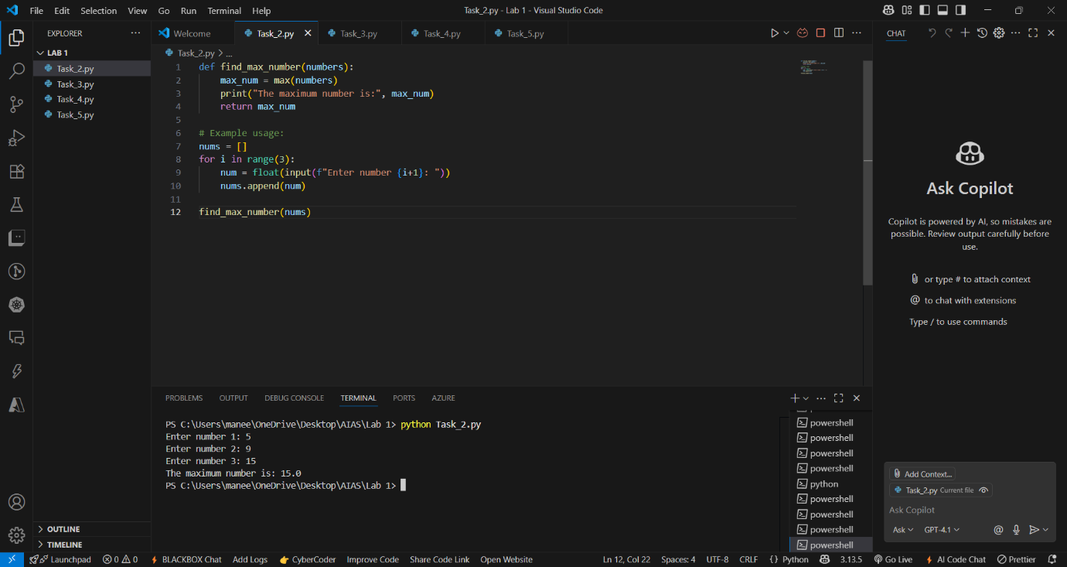

**Task Description #3  
•** Use GitHub Copilot to create a recursive Python function that calculates the factorial of a number.

**Expected Output #3  
•** Python function for factorial using recursion with input and output examples.

Prompt: Create a python function using recursive to find the factorial of a given number take a number as input as a dynamic value and print the output

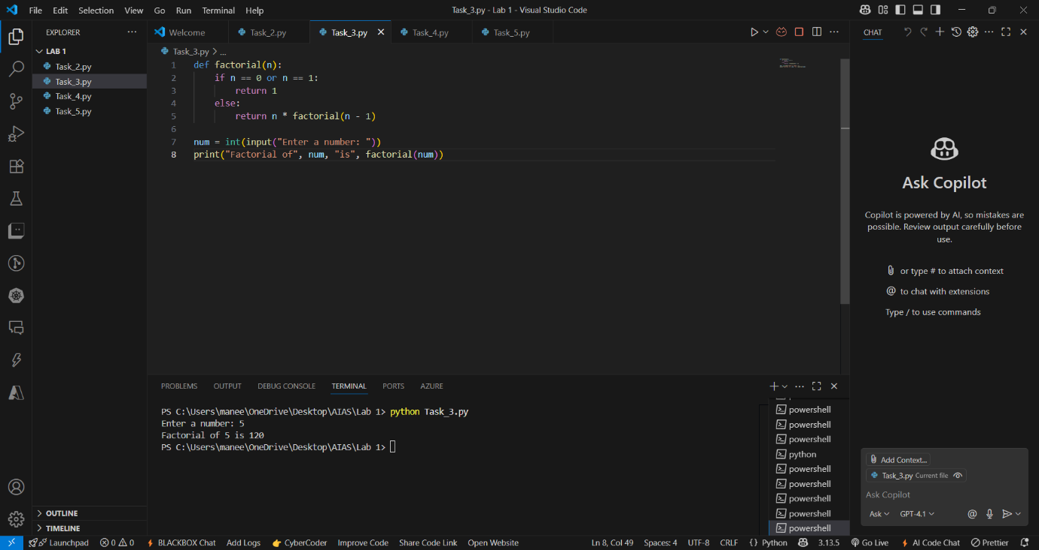

**Task Description #4  
•** Prompt GitHub Copilot to create a class named Student with attributes name, roll_no, and marks. Add a method to display student details.

**Expected Output #4  
•** Python class definition with an initializer and a display method. Include object creation and output.

Prompt: Create a Python program where it should create a class with Student name ,roll no and marks add a method with in the class and include object creation display the student details and take the input as dynamic

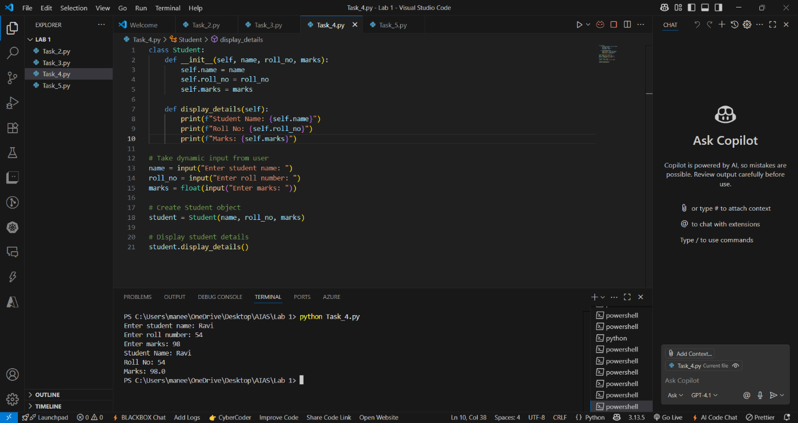

**Task Description #5  
•** Ask GitHub Copilot to generate a Python function that takes a string as input and returns the frequency of each word.

**Expected Output #5  
•** Python function that returns word frequency using a dictionary. Provide sample input and output.

Prompt : Create a Pytho function where the user give the string as dynamic input that return frequency of each word using dictionary and display the output

